|  |  |
| --- | --- |
| Stella Nova Logo | LOGO4 |
| Best Buy Canada Mobile | |
| |  | | --- | | **Gift Card Feature Document** |   **Document Version: 1.2**  **Design Date: January 11, 2013** | |
| **Prepared By: Amy Lackas** | |
|  | |

**Table of Contents**

*1.**Feature Overview* 4

1.1 Feature Description 4

1.2 Assumptions 4

1.3 Parameters and System Settings 4

1.4 Interfaces 4

*2.**USE CASE: Gift Card Issue* 5

2.1 Feature Flow 5

2.2 Precondition 5

2.3 Main Flow 5

2.4 Alternate Flows 6

2.5 Post Condition 6

2.6 Special Requirements 7

*3.**USE CASE: Gift Card Activation/Deactivation/Reload* 8

3.1 Feature Flow 8

3.2 Precondition 8

3.3 Main Flow 8

3.4 Alternate Flows 9

3.5 Post Condition 9

3.6 Special Requirements 9

*4.**USE CASE: Gift Card Balance Inquiry* 10

4.1 Feature Flow 10

4.2 Precondition 10

4.3 Main Flow 10

4.4 Alternate Flows 11

4.5 Post Condition 11

4.6 Special Requirements 11

*5.**USE CASE: Gift Card Reload* 12

5.1 Feature Flow 12

5.2 Precondition 12

5.3 Main Flow 12

5.4 Alternate Flows 12

5.5 Post Condition 13

5.6 Special Requirements 13

*6.**USE CASE: Gift Card Tender* 14

6.1 Feature Flow 14

6.2 Precondition 14

6.3 Main Flow 14

6.4 Alternate Flows 15

6.5 Post Condition 15

6.6 Special Requirements 15

*7.**USE CASE: Gift Card Authorization* 16

7.1 Feature Flow 16

7.2 Precondition 16

7.3 Main Flow 16

7.4 Alternate Flows 16

7.5 Post Condition 16

7.6 Special Requirements 16

*8.**Supplemental Specifications* 17

8.1 Electronic Journal 17

8.2 Manager Override 17

8.3 Modify Transaction 17

8.4 POSLog 17

8.5 Printed Receipts 17

*9.**Screen Layouts* 18

9.1 Gift Card Amount 18

9.2 Gift Card 19

9.3 Capture PIN Number 21

9.4 Authorizing 22

*10.**Business Sign Off* 23

*11.**Revision History* 23

12. Appendix A: Source Documentation 24

12.1 Functional Requirements 24

*13.**Appendix* B*: Glossary* 24

# *Feature Overview*

## Feature Description

The popularity of gift cards has steadily increased as gift cards make great gifts and are convenient to purchase. For retailers, gift cards equate to high margins as they sell themselves and require little space on the sale floor making gift cards ideal items to place near registers. This makes the process of issuing or selling a gift card important to both the customer and the retailer.

The Gift Card Feature Document describes the process to issue or sell a gift card either for a predetermined amount , the functionality to activate a gift card that has been issued, the process to accept a gift card as a form of tender and to authorize the gift card tender amount.

## Assumptions

1. An external processor handles the administration of gift cards.
2. Gift Cards are sold as SKUs.
3. Gift card IDs can be manually entered, swiped, or scanned. Swipe and scan are implied enters.
4. Gift Cards are non taxable and not eligible for item or transaction level manual tax overrides.
5. Gift Cards are not eligible for quantity or price modifications
6. A transaction can have multiple gift card tenders.
7. The authorization process occurs individually when there are multiple gift card tenders.
8. The system attempts to authorize every Gift Card either manually or systematically, when used as a tender.
9. The system does not allow gift cards to be cashed out. If the gift card has a balance greater than balance due during the tender process, the system will not cash out the balance remaining on the card.
10. The BIN file is maintained by the retailer.
11. All text displayed by the system is configurable by brand to support multi-language.  Text is defined from an external source or defined within the system.

## Parameters and System Settings

|  |  |  |
| --- | --- | --- |
| **Parameter Mnemonic** | **Description** | **Valid Values** |
| Minimum Gift Card Issue Amount | A system limit that determines the minimum issue amount of a gift card. | 0.00 to 9999.99 |
| Maximum Gift Card Issue Amount | A system limit that determines the maximum issue amount of a gift card. | 0.00 to 9999.99 |
| Gift Card Activation Timeout | Determines the length of time (in seconds) the system waits before timing out during a Gift Card Activation request. | 1 to 60 |
| Allow Card Details to be Manually Entered by Card Type | Determines by card type (ie, Visa, Mastercard, American Express, Debit) if the account number and expiration date can be manually entered. | * On * Off |
| Manual Capture Gift Credit Card Account Number Manager Override | Determines if manager override is required when the card’s account number is manually captured | * On * Off |
| Minimum Gift Card Reload Amount | A system limit that determines the minimum reload amount of a gift card. | 0.00 to 9999.99 |
| Maximum Gift Card Reload Amount | A system limit that determines the maximum reload amount of a gift card. | 0.00 to 9999.99 |

## Interfaces

|  |  |
| --- | --- |
| **Interface** | **Description** |
| BBTG Tender Authorization Service | External processor that handles the administration of gift cards and credit card. |

# *USE CASE: Gift Card Issue*

## Feature Flow



## Precondition

* The operator has added a Gift Card item to a basket.
* The operator has selected to issue a gift card by selecting an Issue option

## Main Flow

1. The system prompts the operator to enter the gift card ID.
2. If the operator manually enters the gift card ID, the Manual Gift Card Entry alternate flow is executed.
3. If the operator scans the gift card ID, the Gift Card Scan Entry alternate flow is executed.
4. The operator swipes the gift card.
5. If the swipe is unsuccessful, the system displays a message, the operator acknowledges the message and the Main Flow restarts.
6. The system validates the gift card ID.
7. If the gift card ID is invalid, the system displays a message, the operator acknowledges the message and the Main Flow restarts.
8. The system determines if a gift card amount is required.
9. If an amount is required, the Gift Card Amount alternate flow is executed.
10. The system journals the gift card ID, entry method and amount.
11. The use case ends and the system executes the Gift Card Activation use case.

## Alternate Flows

### Manual Gift Card Entry

1. The operator enters the gift card ID and accepts the entry.
2. The system determines if a Check Digit computation is required.
3. If a Check Digit computation is required, the Check Digit use case is executed.
4. If the system returns from the Check Digit use case with an invalid check digit, the system displays a message, the operator acknowledges the message and the Main Flow restarts.
5. The system evaluates if manager override is required for manually capturing the account number.
6. If the manager override is not required for manually capturing the card account number, the system returns to the Main Flow where the system determines if a gift card amount is required.
7. The system executes the Manager Override use case.
8. If the manager override is denied, the use case ends and the system returns to the calling use case.
9. If the Manager Override use case returns with an approved, the system returns to the Main Flow where the system determines if a gift card amount is required. **Note**: The manager override is not queued, as the manager override occurred after total is selected.

### Gift Card Scan Entry

1. If the scan is unsuccessful, the system restarts the Main Flow.
2. The device reads the gift card information from the bar code.
3. The system returns to the Main Flow where the system determines if a gift card amount is required.

### Gift Card Amount

1. The system prompts the operator to enter the amount of the gift card.
2. The operator enters an amount and accepts the entry.
3. The system evaluates the gift card amount.
4. If the amount is less than the Minimum Gift Card Issue Amount parameter, the system displays a message, the operator acknowledges the message and the alternate flow restarts.
5. If the amount is greater than the Maximum Gift Card Issue Amount parameter, the system displays a message, the operator acknowledges the message and the alternate flow restarts.
6. The alternate flow ends and the system returns to the Main Flow where the system journals the gift card ID, entry method and amount.

## Post Condition

* Gift Card activation is executed

## Special Requirements

Open value gift cards will prompt for the amount to apply.

### Special Offline Requirements

TBD

### Data Input/Output

|  |  |  |
| --- | --- | --- |
| **Data Element** | **Description** | **Destination** |
| SKU | The SKU associated with the gift card to be issued | * E-Journal * POSLog * Receipt |
| Gift Card Number | Number associated to a gift card | * E-Journal * Receipt * POSLog |
| Gift Card Number (Receipt | The number associated to a gift card. The number is masked on the receipt | * Receipt. |
| Entry Method | The method the gift card was entered into the system:   * Swiped * Scan * Manual Entry | * E-Journal * POSLog * Receipt |
| Amount | The issued amount on the gift card – either the amount in the database or amount entered for the open value gift card. | * E-Journal * Receipt * POSLog |

# *USE CASE: Gift Card Activation/Deactivation/Reload*

## Feature Flow



## Precondition

* A gift card has been issued or a gift card item is being voided.

## Main Flow

1. The system sends an Activation or Deactivation message to the authorization service.
2. The system receives a response.
3. If the message was for Deactivation, the system journals the authorization details, the use case ends and returns to the calling use case.
4. If the system is offline to the authorization service or times out, the system displays a message, the operator acknowledges the message, the use case continues where the system journals the authorization details.
5. If the response is Declined, the system discards the gift card, journals the gift card ID and the decline response, the use case continues where the system journals the authorization details.
6. If the response is an approval, the system journals the gift card ID, gift card amount, the date the gift card was sold, activation response (activated or deactivated).
7. The system journals the authorization details.
8. The use case ends and the system returns to the calling use case.

## Alternate Flows

## Post Condition

* A Gift Card is activated or deactivated.

## Special Requirements

All gift card deactivation responses are processed as an approved.

### Special Offline Requirements

TBD

### Data Input/Output

|  |  |  |
| --- | --- | --- |
| **Data Element** | **Description** | **Destination** |
| Gift Card Number | The number associated to a gift card | * E-Journal * POSLog |
| Amount | The issued amount on the gift card | * E-Journal * POSLog * Receipt |
| Date | Date the gift card was activated | * E-Journal * POSLog * Receipt |
| Balance Amounts | The Original Balance, Transaction Amount and Remaining Balance for the gift card number. Original Balance returned from authorization service. | * Receipt |
| Activation Response | Response from Gift Card Processer: Activated | * E-Journal |

# *USE CASE: Gift Card Balance Inquiry*

## Feature Flow



## Precondition

* Gift Card Balance Inquiry Selected

## Main Flow

1. The system prompts the operator to enter the gift card ID.
2. If the operator manually enters the gift card ID, the Manual Gift Card Entry alternate flow is executed.
3. If the operator scans the gift card ID, the Gift Card Scan Entry alternate flow is executed.
4. The operator swipes the gift card.
5. If the swipe is unsuccessful, the system displays a message, the operator acknowledges the message and the Main Flow restarts.
6. The system queries gift card ID.
7. If the gift card ID is invalid, the system displays a message, the operator acknowledges the message and the Main Flow restarts.
8. The system prints balance inquiry chit.

## Alternate Flows

### Manual Gift Card Entry

1. The operator enters the gift card ID and accepts the entry.
2. The system determines if a Check Digit computation is required.
3. If a Check Digit computation is required, the Check Digit use case is executed.
4. If the system returns from the Check Digit use case with an invalid check digit, the system displays a message, the operator acknowledges the message and the Main Flow restarts.
5. The system evaluates if manager override is required for manually capturing the account number.
6. If the manager override is not required for manually capturing the card account number, the system returns to the Main Flow where the system determines if a gift card amount is required.
7. The system executes the Manager Override use case.
8. If the manager override is denied, the use case ends and the system returns to the calling use case.
9. If the Manager Override use case returns with an approved, the system returns to the Main Flow where the system determines if a gift card amount is required. **Note**: The manager override is not queued, as the manager override occurred after total is selected.

### Gift Card Scan Entry

1. If the scan is unsuccessful, the system display message, the operator acknowledges the message and restarts the Main Flow.
2. The device reads the gift card information from the bar code.
3. The system returns to the Main Flow where the system determines if a gift card amount is required.

## Post Condition

* Balance Inquiry Chit prints.

## Special Requirements

* User can complete a balance inquiry without starting a transaction or within a sale Transaction.

# *USE CASE: Gift Card Reload*

## Feature Flow



## Precondition

* The operator has selected to reload a gift card by selecting a Reload option

## Main Flow

1. The system prompts the operator to enter the gift card ID.
2. If the operator manually enters the gift card ID, the Manual Gift Card Entry alternate flow is executed.
3. If the operator scans the gift card ID, the Gift Card Scan Entry alternate flow is executed.
4. The operator swipes the gift card.
5. If the swipe is unsuccessful, the system displays a message, the operator acknowledges the message and the Main Flow restarts.
6. The system validates the gift card ID.
7. If the gift card ID is invalid, the system displays a message, the operator acknowledges the message and the Main Flow restarts.
8. The Gift Card Amount alternate flow is executed.
9. The system journals the gift card ID, entry method and amount.
10. The use case ends and the system executes the Gift Card Reload use case.

## Alternate Flows

### Manual Gift Card Entry

1. The operator enters the gift card ID and accepts the entry.
2. The system determines if a Check Digit computation is required.
3. If a Check Digit computation is required, the Check Digit use case is executed.
4. If the system returns from the Check Digit use case with an invalid check digit, the system displays a message, the operator acknowledges the message and the Main Flow restarts.
5. The system evaluates if manager override is required for manually capturing the account number.
6. If the manager override is not required for manually capturing the card account number, the system returns to the Main Flow where the system determines if a gift card amount is required.
7. The system executes the Manager Override use case.
8. If the manager override is denied, the use case ends and the system returns to the calling use case.
9. If the Manager Override use case returns with an approved, the system returns to the Main Flow where the system determines if a gift card amount is required. **Note**: The manager override is not queued, as the manager override occurred after total is selected.

### Gift Card Scan Entry

1. If the scan is unsuccessful, the system restarts the Main Flow.
2. The device reads the gift card information from the bar code.
3. The system returns to the Main Flow where the system determines if a gift card amount is required.

### Gift Card Amount

1. The system prompts the operator to enter the amount of the gift card.
2. The operator enters an amount and accepts the entry.
3. The system evaluates the gift card amount.
4. If the amount is less than the Minimum Gift Card Reload Amount parameter, the system displays a message, the operator acknowledges the message and the alternate flow restarts.
5. If the amount is greater than the Maximum Gift Card Reload Amount parameter, the system displays a message, the operator acknowledges the message and the alternate flow restarts.
6. The alternate flow ends and the system returns to the Main Flow where the system journals the gift card ID, entry method and amount.

## Post Condition

* Gift Card reload is executed

### Data Input/Output

|  |  |  |
| --- | --- | --- |
| **Data Element** | **Description** | **Destination** |
| SKU | The SKU associated with the gift card to be issued | * E-Journal * POSLog * Receipt |
| Gift Card Number | Number associated to a gift card | * E-Journal * Receipt * POSLog |
| Gift Card Number (Receipt | The number associated to a gift card. The number is masked on the receipt | * Receipt. |
| Entry Method | The method the gift card was entered into the system:   * Swiped * Scan * Manual Entry | * E-Journal * POSLog * Receipt |
| Amount | The reloaded amount on the gift card. | * E-Journal * Receipt * POSLog |

## Special Requirements

* User can complete a Gift Card Reload without starting a transaction or within a sale Transaction.

# *USE CASE: Gift Card Tender*

## Feature Flow



## Precondition

* Gift Card tender information is collected

## Main Flow

1. The system prompts the operator to enter the gift card number.
2. If the operator enters the gift card number via a swipe, the Gift Card Swipe alternate flow is executed.
3. If the operator enters the gift card number via a scan, the Gift Card Scan alternate flow is executed.
4. If the operator enters the gift card number manually, the Manual Entry alternate flow is executed
5. The system validates the gift card number entered by checking the BIN Range.
6. If the gift card number is invalid, the system displays a message, the operator acknowledges the message, and the system returns to the Main Flow where the system prompts the operator to enter the gift card number.
7. The system prompts to capture the PIN number for the store credit card.
8. The operator enters in the data and accepts the entry.
9. The use case ends and the system executes the Gift Card Authorization use case.

## Alternate Flows

### Gift Card Swipe

1. If the swipe is unsuccessful, the system displays a message; the operator acknowledges the message and the system returns to the Main Flow where the system prompts the operator to enter the gift card number.
2. The device reads the data on the magnetic stripe and sends the information to the system.
3. The system returns to the Main Flow where the system validates the gift card number.

### Gift Card Scan

1. If the scan is unsuccessful, the system returns to the Main Flow where the system prompts the operator to enter the gift card number.
2. The device reads the information on the bar code and sends the information to the system.
3. The system returns to the Main Flow where the system validates the gift card number.

### Manual Entry

1. The system evaluates if manager override is required for manually capturing the account number.
2. If the manager override is not required for manually capturing the card account number, the system returns to the Main Flow where the system validates the gift card number.
3. The system executes the Manager Override use case.
4. If the manager override is denied, the use case ends and the system returns to the calling use case.
5. If the Manager Override use case returns with an approved, the system returns to the Main Flow where the system validates the gift card number. **Note**: The manager override is not queued, as the manager override occurred after total is selected.

## Post Condition

* Gift Card information is collected and the Gift Card Authorization use case is executed.

## Special Requirements

None

### Special Offline Requirements

TBD

### Data Input/Output

|  |  |  |
| --- | --- | --- |
| **Data Element** | **Description** | **Destination** |
| Gift Card Number | The entered Gift Card number | * E-journal |
| Entry Method | The method the gift card was entered into the system:   * Swiped * Scan * Manual Entry | * E-journal * Receipt * POSLog |

# *USE CASE: Gift Card Authorization*

## Feature Flow



## Precondition

* Gift Card tender information is collected

## Main Flow

1. The system displays a message indicating that gift card authorization request is in progress.
2. The system sends an authorization request to the authorization service.
3. If the system is offline to the Authorizer or times out before receiving a response, the system displays an error message, the operator acknowledges the message, the use case ends and the system returns to the calling use case.
4. The system receives a response from the authorization service.
5. If the response is declined, the system displays a message, the operator acknowledges the message, and the main flow continues where the system journals the authorization details.
6. If the response is an approval, the approval information for the tender amount returned from authorization service is added to the transaction and main flow continues where the system journals the authorization details.
7. The system journals and logs the card number and authorization details.
8. The use case ends and the system returns to the Tender use case.

## Alternate Flows

None

## Post Condition

* A Gift Card tender is authorized.

## Special Requirements

The amount to apply to the gift card tender is either the returned Gift Card value from the authorization service or the transaction balance due amount, whichever is less.

### Special Offline Requirements

TBD

### Data Input/Output

|  |  |  |
| --- | --- | --- |
| **Data Element** | **Description** | **Destination** |
| Gift Card Number | The entered Gift Card number. The full number written to the POSLog and E-Journal. | * E-journal * POSLog |
| Gift Card Number (Receipt) | The entered gift card number. The Gift Card Number is masked on the receipt. | * Receipt |
| Gift Card Amount | The amount returned from the authorization service to apply to the gift card tender | * E-journal * POSLog * Receipt |
| Entry Method | The method the gift card was entered into the system:   * Swiped * Scan * Manual Entry | * E-journal * POSLog * Receipt |
| Approval Code | Authorization number returned from Authorization service for the activation or tender authorization. | * E-journal * POSLog |
| Balance Amounts | The Original Balance, Transaction Amount and Remaining Balance for the gift card number. Original Balance returned from authorization service. | * Receipt |

# *Supplemental Specifications*

## Electronic Journal

Electronic journal mockups for this feature are documented in the Electronic Journal document.

## Manager Override

The Manager Override feature is called if manager approval is required for capturing the gift card account number manually.

## Modify Transaction

The Modify Transaction feature is updated to not allow a transaction to be suspended if a gift card has been issued in the transaction.

## POSLog

POSLog mockups for this feature are documented in the POSLog document.

## Printed Receipts

Printed receipt mockups, where applicable, are documented in the Receipt Generation document.

# *Screen Layouts*

## Gift Card Amount

The Gift Card Amount screen is displayed when the operator sells an open value gift card that requires an amount to be entered prior to activating the card.

### Mockup

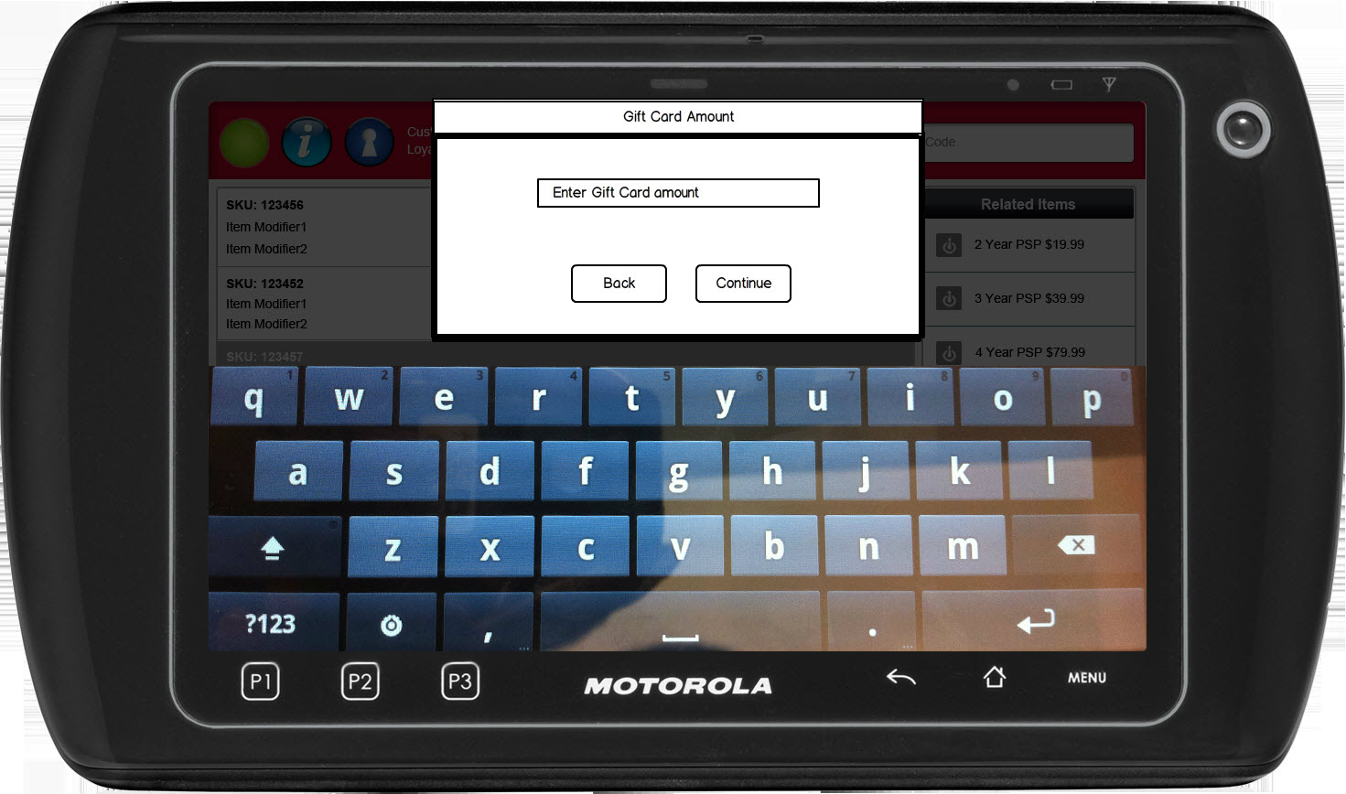

Figure 1: Gift Card Amount

### Instruction Text

|  |
| --- |
| **Instructions** |
| Gift Card Amount |

### Navigation/Menu Key

|  |  |  |  |
| --- | --- | --- | --- |
| **Label** | **State** | **Next Screen** | **Notes** |
| Back | Enabled | * Sale use case | None |
| Continue | See notes | * Invalid Gift Card Amount: Gift Card Amount * Valid Gift Card Amount: Gift Card | Enabled upon data entry |

### Data/Input Field

|  |  |  |  |  |  |  |
| --- | --- | --- | --- | --- | --- | --- |
| **Label** | **Editable** | **Req’d?** | **Data Type** | **Min**  **Length** | **Max**  **Length** | **Notes** |
| Gift Card Amount | Yes | Yes | Dollar | 4 | 12 |  |

### Reason Code

|  |  |  |
| --- | --- | --- |
| **Reason Code** | **Valid Values** | **Default Value** |
| None |  |  |

### Invalid Gift Card Amount

|  |  |
| --- | --- |
| **Description** | The Invalid Gift Card Amount message appears when the gift card amount is greater than less than the minimum and maximum amount parameters. Acknowledging the message returns the operator to the Gift Card Amount screen. |
| **Message** | The gift card amount entered is invalid. |
| **Key prompt** | OK |
| **Notes** | Configurable message |

## Gift Card

The Gift Card screen is displayed when the operator selects to use a gift card as a form of tender or issuing a gift card. The screen prompts the entry of the gift card number through swipe, scan or by manual entry. Swiping and scanning are implied enters.

### Mockup

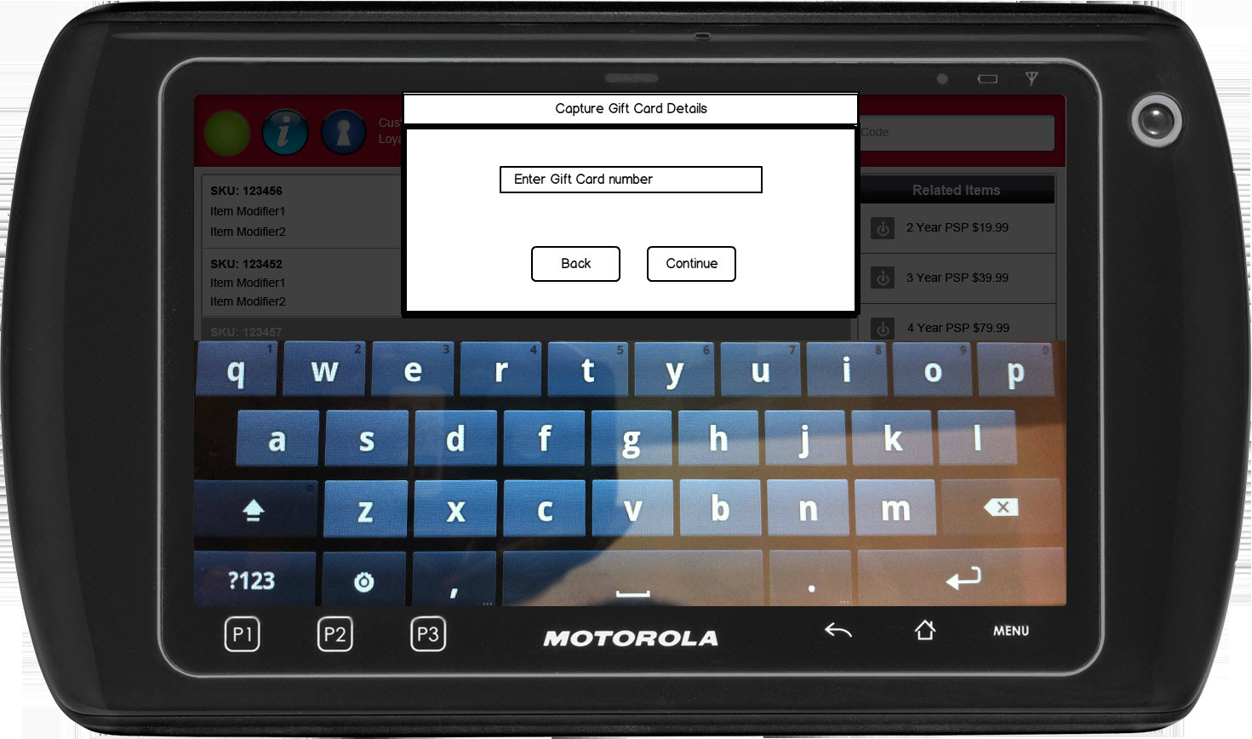

Figure 2: Gift Card

### Instruction Text

|  |
| --- |
| **Instructions** |
| Capture Gift Card Details |

### Navigation/Menu Key

|  |  |  |  |
| --- | --- | --- | --- |
| **Label** | **State** | **Next Screen** | **Notes** |
| Back | Enabled | * Gift Card Tender: Tender use case * Gift Card Issue/Activation: Sale use case | None |
| Continue | See notes | * Invalid Card: Invalid Card * Gift Card Tender: Tender use case * Gift Card Issue/Activation: Tender use case | Enabled upon data entry |
| Swipe | Enabled | * Invalid Card: Invalid Card * Gift Card Tender: Tender use case * Gift Card Issue/Activation: Tender use case | None |
| Scan | Enabled | * Invalid Card: Invalid Card * Gift Card Tender: Tender use case * Gift Card Issue/Activation: Tender use case | None |

### Data/Input Field

|  |  |  |  |  |  |  |
| --- | --- | --- | --- | --- | --- | --- |
| **Label** | **Editable** | **Req’d?** | **Data Type** | **Min**  **Length** | **Max**  **Length** | **Notes** |
| Gift Card Number | Yes | Yes | Numeric | 1 | 20 |  |

### Reason Code

|  |  |  |
| --- | --- | --- |
| **Reason Code** | **Valid Values** | **Default Value** |
| None |  |  |

### Invalid Gift Card

|  |  |
| --- | --- |
| **Description** | The Invalid Gift Card message appears when the gift card is found to be invalid due to failing the BIN Range check. Acknowledging the message returns the operator to the Gift Card screen. |
| **Message** | The gift card number entered is invalid. |
| **Key prompt** | OK |
| **Notes** | Configurable message |

### Bad Card Swipe

|  |  |
| --- | --- |
| **Description** | The Bad Card Swipe message is displayed when the card swipe was unsuccessful and prompts the operator to retry the card swipe or manually enter the card information. Acknowledging the message returns the operator to the Gift Card screen. |
| **Message** | The <ARG> swipe was unsuccessfully. Please retry or enter the information manually. |
| **Key prompt** | OK |
| **Notes** | This is a generic message used for multiple cards. <ARG> is replaced with the card type: Credit Card, Debit Card, Gift Card |

## Capture PIN Number

The Capture PIN Number screen appears when the store credit card used as the tender. The screen appears for store credit cards that are manually entered or swiped.

### Mockup

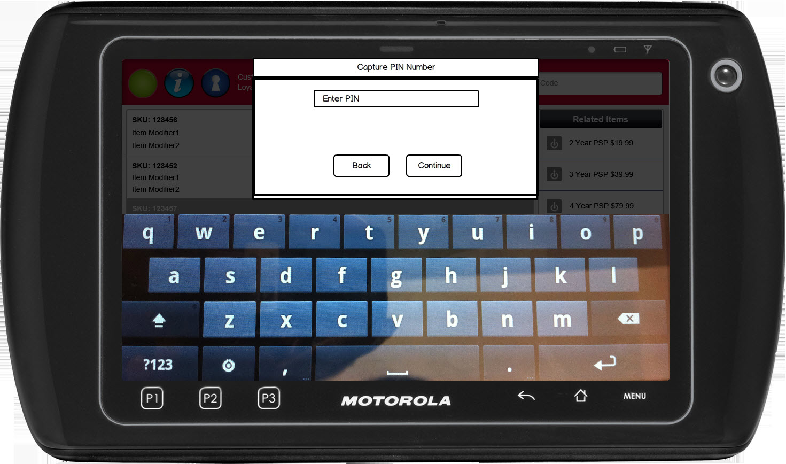

Figure 3: Capture PIN Number

### Instruction Text

|  |
| --- |
| **Instructions** |
| Call for Referral |

### Navigation/Menu Key

|  |  |  |  |
| --- | --- | --- | --- |
| **Label** | **State** | **Next Screen** | **Notes** |
| Back | Enabled | * Tender Use Case |  |
| Continue | See Notes | * Authorizing | Enabled upon entry of value in the Enter PIN field. |

### Data/Input Field

|  |  |  |  |  |  |  |
| --- | --- | --- | --- | --- | --- | --- |
| **Label** | **Editable** | **Req’d?** | **Data Type** | **Min**  **Length** | **Max**  **Length** | **Notes** |
| Enter PIN | Yes | Yes | Numeric | 1 | 4 | None |

### Reason Code

|  |  |  |
| --- | --- | --- |
| **Reason Code** | **Valid Values** | **Default Value** |
| None |  |  |

## Authorizing

The Authorizing screen is displayed when the gift card is being activated/deactivated or authorizing the gift card as a tender. The screen notifies the operator that authorization is occurring.

### Mockup

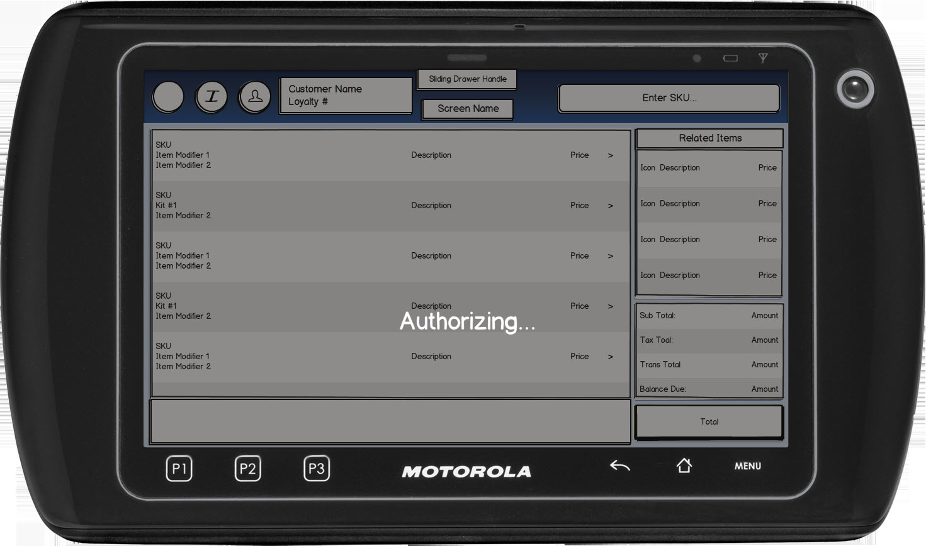

Figure 4: Gift Card

### Instruction Text

|  |
| --- |
| **Instructions** |
| Authorizing… |

### Navigation/Menu Key

|  |  |  |  |
| --- | --- | --- | --- |
| **Label** | **State** | **Next Screen** | **Notes** |
| None |  |  |  |

### Data/Input Field

|  |  |  |  |  |  |  |
| --- | --- | --- | --- | --- | --- | --- |
| **Label** | **Editable** | **Req’d?** | **Data Type** | **Min**  **Length** | **Max**  **Length** | **Notes** |
| None |  |  |  |  |  |  |

### Reason Code

|  |  |  |
| --- | --- | --- |
| **Reason Code** | **Valid Values** | **Default Value** |
| None |  |  |

### Authorization Offline

|  |  |
| --- | --- |
| **Description** | The Authorization Offline message is displayed when the response returns an offline or times out before receiving a response. The <ARG> is replaced with one of the following responses:  “Gift card processor is offline.” “The request has timed out.” Upon acknowledging the message, the system displays the Call for Referral screen. |
| **Message** | The following error occurred during gift card authorization: <ARG> |
| **Key prompt** | OK |
| **Notes** | This is the same message used in Gift Card Authorization. |

### Declined

|  |  |
| --- | --- |
| **Description** | The Declined message is displayed when the response returns a Declined response. The <ARG> is replaced with the error returned from the Authorizer (e.g. Insufficient funds).  Acknowledging the alert returns the operator to the calling use case. |
| **Message** | The card was declined due to <ARG> |
| **Key prompt** | OK |
| **Notes** | This is the same message used in Gift Card Authorization. |

# *Business Sign Off*

|  |  |  |
| --- | --- | --- |
| **Name** | **Organization** | **Date** |
| <Name of signer> | <Organization of signer if applicable> | <date of sign off> |

# *Revision History*

|  |  |  |  |
| --- | --- | --- | --- |
| **Reviser** | **Revision** | **Date** | **Version** |
| Amy Lackas | Initial document created | 01/11/2013 | 1.0 |
| Amy Lackas | Updates after internal review | 01/19/2013 | 1.1 |
| Amy Byers | Added sections for Gift Card Balance Inquiry and Reload and added requirements matrix | 9/26/2014 | 1.2 |

# Appendix : Source Documentation

* Requirement Specification - XPOS.xlsx

## Functional Requirements

| **ID** | **Sub Category** | **Description** | **Section(s)** |
| --- | --- | --- | --- |
| 2.43 | Gift Card Balance Inquiry | XPOS will allow a user to perform a Gift Card Balance Inquiry, without starting a transaction or within a transaction. | * 4.6 Special Requirements |
| 2.43.1 | Gift Card Balance Inquiry | A Gift Card Balance Inquiry may be performed within any Sale. | * 4.6 Special Requirements |
| 2.44 | Gift Card Balance Inquiry | A user will be able to validate the balance on a Gift Card or Store Credit (Store Value Card). | * 4 USE CASE: Gift Card Balance Inquiry |
| 2.45 | Gift Card Balance Inquiry | A user will be able to swipe, scan or manually enter (on the Signature Capture Device) the Gift Card/SVC to perform the balance inquiry. | * 4 USE CASE: Gift Card Balance Inquiry |
| 2.48 | Gift Card Reload | XPOS will allow a user to perform a Gift Card Reload, without starting a transaction or within a transaction. | * 5.6 Special Requirements |
| 2.48.1 | Gift Card Reload | A Gift Card Reload may be performed within any Sale transaction type. | * 5.6 Special Requirements |
| 2.49 | Gift Card Reload | A user will be able to swipe, scan or manually enter (on the signature capture device) the Gift Card to reload funds to the card. | * 5 USE CASE: Gift Card Reload |
| 2.50 | Gift Card Reload | A user will be able to reload a Gift Card only. Store Credit (Store Value Card) are not reloadable. | * 5 USE CASE: Gift Card Reload |
| 2.50.1 | Gift Card Reload | Should a user attempt to reload a Store Credit (Store Value Card), an error message indicating that the card type can not have funds added to it, will be displayed to the user. Once acknowledged, the user will be returned to the item entry screen. | * 5 USE CASE: Gift Card Reload |

# *Appendix : Glossary*

|  |  |
| --- | --- |
| **Term** | **Definition** |
| BIN | BIN stands for [Bank Identification Number](http://en.wikipedia.org/wiki/Bank_Identification_Number) and is the first 6 digits of the card (identifies the issuer).  Also known as Issuer Identification Number. A typical BIN file contains a list of number ranges to identify valid cards and to distinguish Debit Cards from Credit Cards and other types of cards such as Pre-Paid Credit Cards and Private Label Credit Cards. |
| Open Value Gift Card | A type of Gift Card that does not have a set balance when issued. |